1. Implementation of a tree with value,parent and children

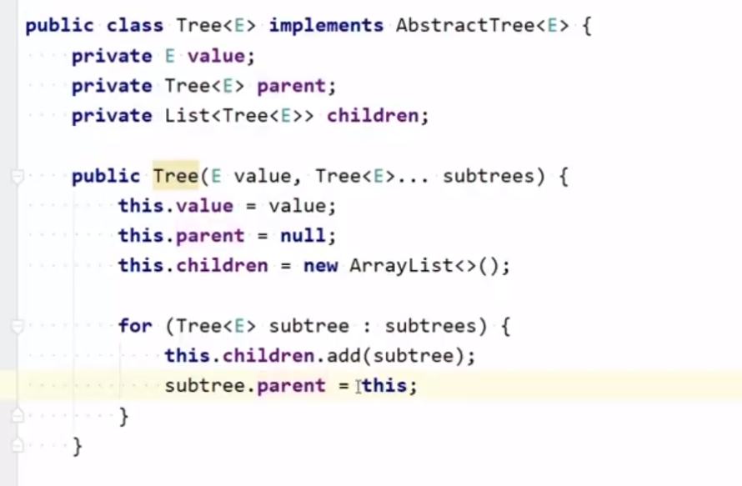

1. Breadth first search (BFS)

* Starts from the root element and adds the nodes on the same row at first (the same level). With a Queue

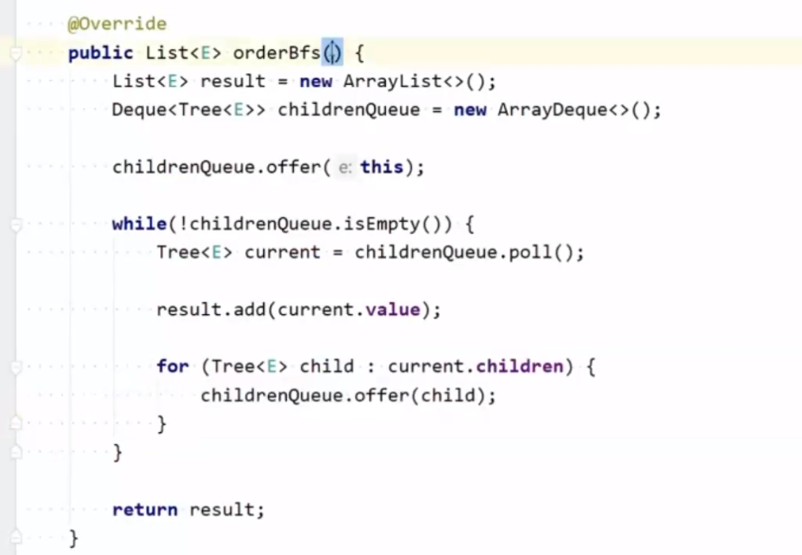

1. Depth First Search (DFS)

* Through recursion

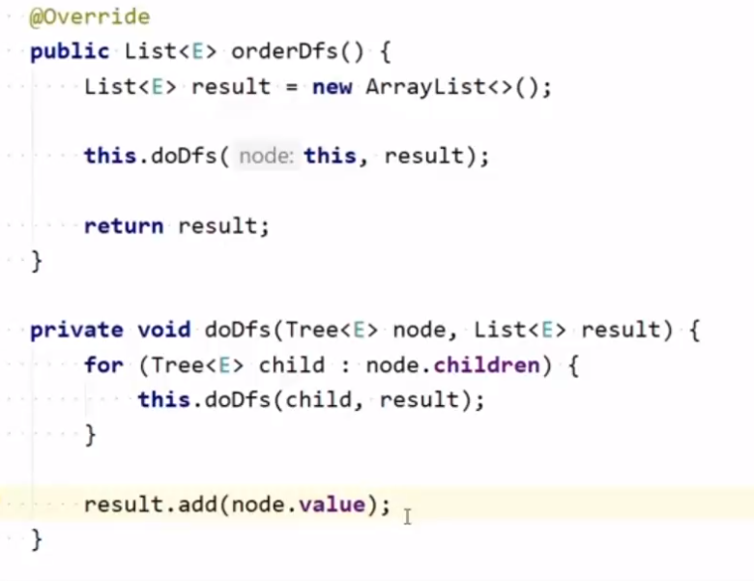

* Stack

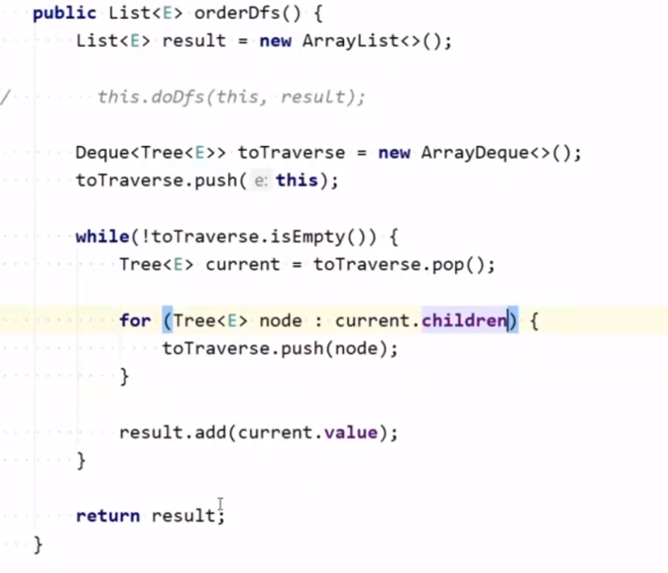

1. Add child to tree

* Add child to children and set parent

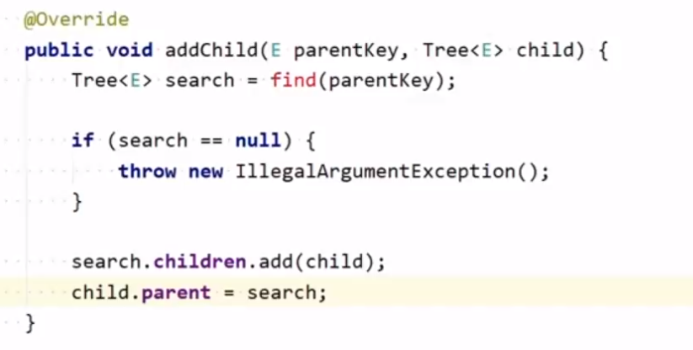

1. Find element

* BFS

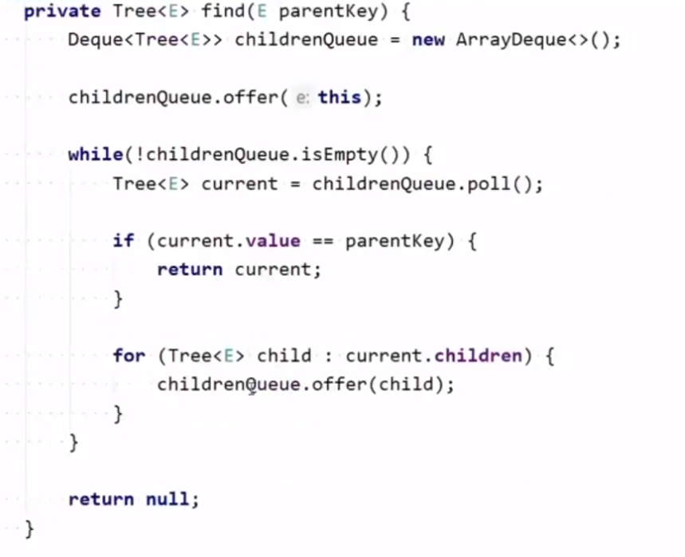

1. Remove tree

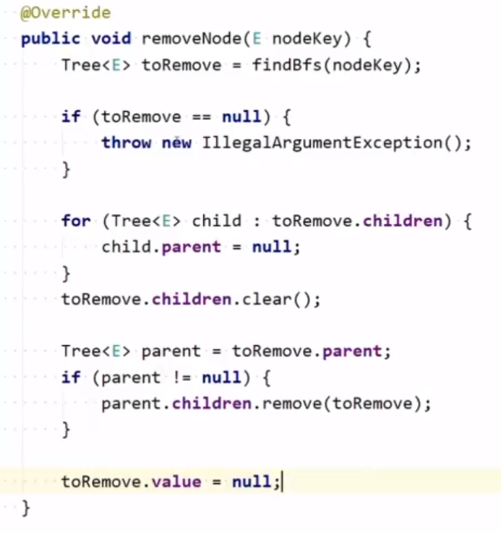

1. Swap nodes

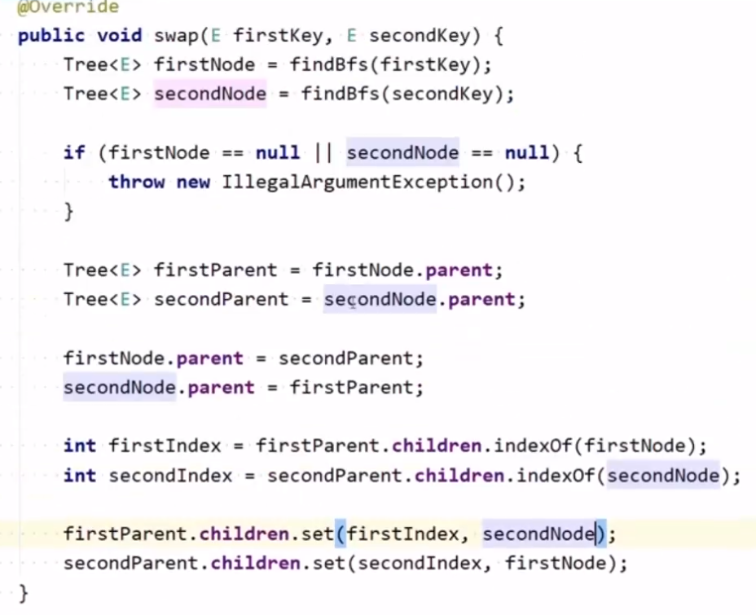

* If any of the elements is the root, this logic should be added right after first and secondParent initialization.

+ secondNode.parent = null or firstNode.parent = null

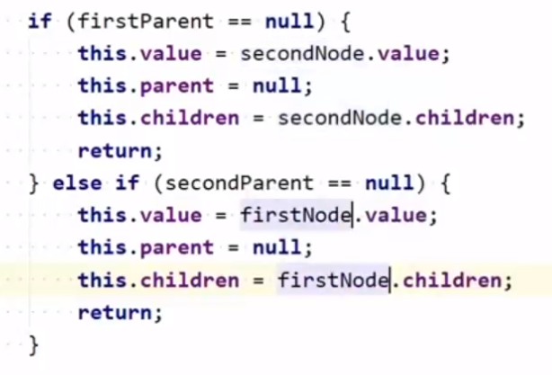

5. Find deepest node

- deepestLeftNode и MaxPath се запазват в някаква структура от данни, защото ако са int променлива ще прави копия, а ако е Tree<E> ще е immutable.

